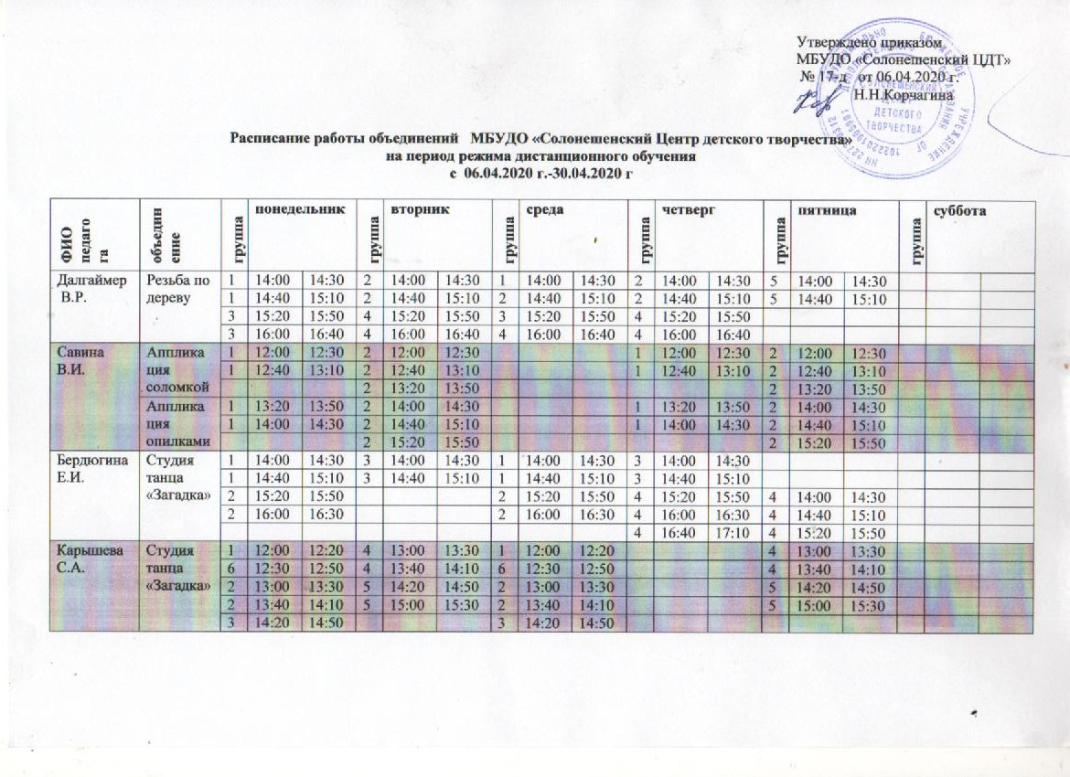
Карышева С.А. | Студия танца «Загадка» | 1 | 12:00 | 12:20 | 4 | 13:00 | 13:30 | 1 | 12:00 | 12:20 |  |  |  | 4 | 13:00 | 13:30
Карышева С.А. | Студия танца «Загадка» | 6 | 12:30 | 12:50 | 4 | 13:40 | 14:10 | 6 | 12:30 | 12:50 |  |  |  | 4 | 13:40 | 14:10
Карышева С.А. | Студия танца «Загадка» | 2 | 13:00 | 13:30 | 5 | 14:20 | 14:50 | 2 | 13:00 | 13:30 |  |  |  | 5 | 14:20 | 14:50
Карышева С.А. | Студия танца «Загадка» | 2 | 13:40 | 14:10 | 5 | 15:00 | 15:30 | 2 | 13:40 | 14:10 |  |  |  | 5 | 15:00 | 15:30
Карышева С.А. | Студия танца «Загадка» | 3 | 14:20 | 14:50 |  |  |  | 3 | 14:20 | 14:50
Карышева С.А. | Студия танца «Загадка» | 3 | 15:00 | 15:30 |  |  |  | 3 | 15:00 | 15:30
Рябых  О.Н. | Студия танца «Загадка» |  |  |  |  |  |  |  |  |  |  |  |  | 1 | 16:00 | 16:30
Рябых  О.Н. | Студия танца «Загадка» | 2 | 13:30 | 14:00 |  |  |  |  |  |  |  |  |  | 2 | 13:30 | 14:00
Рябых  О.Н. | Студия танца «Загадка» | 2 | 14:10 | 14:40 |  |  |  |  |  |  |  |  |  | 2 | 14:10 | 14:40
Рябых  О.Н. | Студия танца «Загадка» | 3 | 15:00 | 15:30 |  |  |  |  |  |  |  |  |  | 3 | 15:00 | 15:30
Рябых  О.Н. | Студия танца «Загадка» | 3 | 15:40 | 16:10 |  |  |  |  |  |  |  |  |  | 3 | 15:40 | 16:10
Рябых  О.Н. | Студия танца «Загадка» | 3 | 16:20 | 16:50 |  |  |  |  |  |  |  |  |  | 3 | 16:20 | 16:50
Рябых  О.Н. | Театр кукол и сказок |  |  |  | 4 | 9:30 | 10:00
Рябых  О.Н. | Театр кукол и сказок |  |  |  | 4 | 10:10 | 10:40
Рябых  О.Н. | художественное слово |  |  |  | 5 | 10:50 | 11:20 |  |  |  | 5 | 10:50 | 11:20
Рябых  О.Н. | художественное слово |  |  |  | 5 | 11:30 | 12:00 |  |  |  | 5 | 11:30 | 12:00
Крохина  Е.П. | Вокально-эстрадная студия «Радость» |  |  |  | 4 | 13:00 | 13:30 | 1 | 12:20 | 12:40 | 4 | 13:00 | 13:30 | 1 | 12:20 | 12:40
Крохина  Е.П. | Вокально-эстрадная студия «Радость» |  |  |  | 4 | 13:40 | 14:10 | 2 | 09:50 | 10:10 | 4 | 13:40 | 14:10 | 2 | 09:50 | 10:10
Крохина  Е.П. | Вокально-эстрадная студия «Радость» | 3 | 13:00 | 13:30 | 4 | 14:20 | 14:50 | 3 | 13:00 | 13:30 | 4 | 14:20 | 14:50
Крохина  Е.П. | Вокально-эстрадная студия «Радость» | 3 | 13:40 | 14:10 |  |  |  | 3 | 13:40 | 14:10
Крохина  Е.П. | Вокально-эстрадная студия «Радость» | 3 | 14:20 | 14:50 |  |  |  | 3 | 14:20 | 14:50
Крохина  Е.П. | Вокально-эстрадная студия «Радость» | 5 | 12:00 | 12:30 |  |  |  |  |  |  |  |  |  | 5 | 12:00 | 12:30
Крохина  Е.П. | Вокально-эстрадная студия «Радость» | 5 | 12:30 | 13:00 |  |  |  |  |  |  |  |  |  | 5 | 12:30 | 13:00
Крянга  А.С. | Шахматы | 1 | 12:00 | 12:20 | 4 | 14:00 | 14:30 | 3 | 13:00 | 13:30 | 4 | 14:00 | 14:30 | 1 | 12:00 | 12:20
Крянга  А.С. | Шахматы | 2 | 12:30 | 12:50 | 4 | 14:40 | 15:10 | 3 | 13:40 | 14:10 | 4 | 14:40 | 15:10 | 2 | 12:30 | 12:50
Крянга  А.С. | Шахматы | 5 | 13:00 | 13:30 |  |  |  | 5 | 14:20 | 14:50 |  |  |  | 3 | 13:00 | 13:30
Крянга  А.С. | Шахматы | 5 | 13:40 | 14:10 |  |  |  | 5 | 16:00 | 16:30 |  |  |  | 3 | 13:40 | 14:10
Крянга  А.С. | Шахматы | 5 | 14:20 | 14:50 |  |  |  | 5 | 16:40 | 17:10
Лагута  А.Н. | Изосту  дия  «Веселая палитра» |  |  |  |  |  |  |  |  |  |  |  |  | 1 | 12:30 | 13:00
Лагута  А.Н. | Изосту  дия  «Веселая палитра» |  |  |  | 2 | 12:30 | 13:00
Лагута  А.Н. | Изосту  дия  «Веселая палитра» |  |  |  | 3 | 13:10 | 13:40 |  |  |  | 3 | 13:10 | 13:40
Лагута  А.Н. | Изосту  дия  «Веселая палитра» |  |  |  | 3 | 13:50 | 14:20 |  |  |  | 3 | 13:50 | 14:20
Лагута  А.Н. | Изосту  дия  «Веселая палитра» |  |  |  | 3 | 14:30 | 15:00 |  |  |  | 3 | 14:30 | 15:00
Лагута  А.Н. | Роспись по дереву | 5 | 13:10 | 13:40 | 4 | 15:00 | 15:30 | 5 | 13:10 | 13:40 |  |  |  | 4 | 15:00 | 15:30
Лагута  А.Н. | Роспись по дереву | 5 | 13:50 | 14:20 | 4 | 15:40 | 16:10 | 5 | 13:50 | 14:20 |  |  |  | 4 | 15:40 | 16:10
Лагута  А.Н. | Роспись по дереву | 5 | 14:30 | 15:00 |  |  |  | 5 | 14:30 | 15:00
Бабицкая  М.В. | Вышивка, худ. вышивка | 1 | 12:00 | 12:30 |  |  |  | 2 | 12:00 | 12:30 | 2 | 12:00 | 12:30
Бабицкая  М.В. | Вышивка, худ. вышивка | 1 | 12:40 | 13:10 |  |  |  | 2 | 12:40 | 13:10 | 2 | 12:40 | 13:10
Бабицкая  М.В. | Вышивка, худ. вышивка | 3 | 13:20 | 13:50 |  |  |  | 3 | 13:20 | 13:50
Бабицкая  М.В. | Вышивка, худ. вышивка | 3 | 14:00 | 14:30 |  |  |  | 3 | 14:00 | 14:30
Бабицкая  М.В. | Вышивка, худ. вышивка | 3 | 14:40 | 15:10 |  |  |  | 3 | 14:40 | 15:10
Бабицкая  М.В. | Бумага- волшебница |  |  |  | 4 | 12:30 | 13:00
Бабицкая  М.В. | Бумага- волшебница |  |  |  | 5 | 11:50 | 12:20
Бабицкая  М.В. | Бумага- волшебница |  |  |  | 6 | 13:10 | 13:40
Бабицкая  М.В. | Театр кукол и сказок |  |  |  |  |  |  |  |  |  | 7 | 9:30 | 10:00 | 8 | 11:00 | 11:20
Бабицкая  М.В. | Азбука экологии | 8 | 10:00 | 10:20 |  | 10:00 | 10:20
Пшеничникова С.Д. | Радуга творчес  тва | 1 | 12:00 | 12:30 | 1 | 12:00 | 12:30 | 2 | 12:00 | 12:30 |  |  |  | 2 | 12:00 | 12:30
Пшеничникова С.Д. | Радуга творчес  тва | 1 | 12:40 | 13:10 | 1 | 12:40 | 13:10 | 2 | 12:40 | 13:10 |  |  |  | 2 | 12:40 | 13:10
Пшеничникова С.Д. | Радуга творчес  тва |  |  |  |  |  |  | 2 | 13:20 | 13:50 |  |  |  | 2 | 13:20 | 13:50
филиал Солонешенская ДЮСШ

Старков  И.В. | Волейбол | 1 | 15:00 | 15:30 | 1 | 15:00 | 15:30 |  |  |  | 1 | 15:00 | 15:30
Старков  И.В. | Волейбол | 1 | 15:40 | 16:10 | 1 | 15:40 | 16:10 |  |  |  | 1 | 15:40 | 16:10
Старков  И.В. | Волейбол | 1 | 16:20 | 16:50 | 1 | 16:20 | 16:50 |  |  |  | 1 | 16620 | 16:50
Старков  И.В. | Волейбол | 2 | 17:00 | 17:30 |  |  |  | 2 | 17:00 | 17:30 |  |  |  | 2 | 17:00 | 17:30
Старков  И.В. | Волейбол | 2 | 17:40 | 18:10 |  |  |  | 2 | 17:40 | 18:10 |  |  |  | 2 | 17:40 | 18:10
Старков  И.В. | Волейбол |  |  |  | 3 | 17:00 | 17:30 |  |  |  | 3 | 17:00 | 17:30 |  |  |  | 3 | 17:00 | 17:30
Старков  И.В. | Волейбол |  |  |  | 3 | 17:40 | 18:10 |  |  |  | 3 | 17:40 | 18:10 |  |  |  | 3 | 17:40 | 18:10
Булгаков  В.В. | Кикбок  синг | 1 |  |  | 1 | 9:30 | 10:00 |  |  |  | 1 | 9:30 | 10:00
Булгаков  В.В. | Кикбок  синг | 1 |  |  | 1 | 10:10 | 10:40 |  |  |  | 1 | 10:10 | 10:40
Булгаков  В.В. | Кикбок  синг |  |  |  | 2 | 10:50 | 11:20 |  |  |  | 2 | 10:50 | 11:20 |  |  |  | 2 | 10:50 | 11:20
Булгаков  В.В. | Кикбок  синг |  |  |  | 2 | 11:30 | 12:00 |  |  |  | 2 | 11:30 | 12:00 |  |  |  | 2 | 11:30 | 12:00
Булгаков  В.В. | Кикбок  синг | 3 | 12:00 | 12:30 |  |  |  | 3 | 12:00 | 12:30 |  |  |  | 3 | 12:00 | 12:30
Булгаков  В.В. | Кикбок  синг | 3 | 12:40 | 13:10 |  |  |  | 3 | 12:40 | 13:10 |  |  |  | 3 | 12:40 | 13:10
Гусев Ю.И. | Лыжи | 1 | 14:00 | 14:30 |  |  |  |  |  |  | 1 | 14:00 | 14:30
Гусев Ю.И. | Лыжи | 1 | 14:40 | 15:10 |  |  |  |  |  |  | 1 | 14:40 | 15:10
Гусев Ю.И. | Лыжи |  |  |  | 2 | 12:00 | 12:30 | 2 | 12:00 | 12:30 |  |  |  | 2 | 12:00 | 12:30
Гусев Ю.И. | Лыжи |  |  |  | 2 | 12:40 | 13:10 | 2 | 12:40 | 13:10 |  |  |  | 2 | 12:40 | 13:10
Гусев Ю.И. | Лыжи |  |  |  | 2 | 13:20 | 13:50 | 2 | 13:20 | 13:50 |  |  |  | 2 | 13:20 | 13:50
Михайлов  П.И. | Лыжи | 1 | 12:00 | 12:30 |  |  |  | 1 | 12:00 | 12:30
Михайлов  П.И. | Лыжи | 1 | 12:40 | 13:10 |  |  |  | 1 | 12:40 | 13:10
Михайлов  П.И. | Лыжи |  |  |  | 2 | 12:00 | 12:30 |  |  |  | 2 | 12:00 | 12:30 | 2 | 12:00 | 12:30
Михайлов  П.И. | Лыжи |  |  |  | 2 | 12:40 | 13:10 |  |  |  | 2 | 12:40 | 13:10 | 2 | 12:40 | 13:10
Новиков  С.Л. | Лыжи | 1 | 12:00 | 12:30 |  |  |  | 1 | 12:00 | 12:30
Новиков  С.Л. | Лыжи | 1 | 12:40 | 13:10 |  |  |  | 1 | 12:40 | 13:10
Новиков  С.Л. | Лыжи |  |  |  | 2 | 12:00 | 12:30 |  |  |  | 2 | 12:00 | 12:30 |  |  |  | 2 | 12:00 | 12:30
Новиков  С.Л. | Лыжи |  |  |  | 2 | 12:40 | 13:10 |  |  |  | 2 | 12:40 | 13:10 |  |  |  | 2 | 12:40 | 13:10

:

